EXPERIMENT – 37
AIM :
To analyze the relationship between students’ study time and exam scores and visualize the correlation using Python.
ALGORITHM :
- Load the dataset (or create sample data if not available).
- Extract study time and exam score columns.
- Calculate the correlation coefficient.
- Plot the relationship using scatter and line plots.
- Interpret whether a correlation exists.

CODE :
import pandas as pd
import matplotlib.pyplot as plt
import os

file_name = "students_data.csv"

# ✅ Load data if file exists, else create sample data
if os.path.exists(file_name):
data = pd.read_csv(file_name)
print("✅ File loaded successfully!")
else:
print("⚠️ File not found! Using sample data...\n")
data = pd.DataFrame({
'Study_Hours': [1, 2, 3, 4, 5, 6, 7, 8],
'Exam_Score': [50, 55, 60, 65, 70, 75, 80, 85]
})

# Extract values
hours = data['Study_Hours']
scores = data['Exam_Score']

# Calculate correlation
correlation = data.corr().loc['Study_Hours', 'Exam_Score']

print("=== Study Time vs Exam Score Analysis ===")
print(f"Correlation Coefficient: {correlation:.2f}")

# Scatter plot
plt.scatter(hours, scores)
plt.title("Study Time vs Exam Score")
plt.xlabel("Study Hours")
plt.ylabel("Exam Score")
plt.grid(True)
plt.show()

# Line plot
plt.plot(hours, scores, marker='o')
plt.title("Trend Line of Study Time vs Exam Score")
plt.xlabel("Study Hours")
plt.ylabel("Exam Score")
plt.grid(True)
plt.show()

INPUT :
A CSV file named students_data.csv with columns:
Study_Hours, Exam_Score
If missing, the program uses sample data automatically.

OUTPUT :
⚠️ File not found! Using sample data...

=== Study Time vs Exam Score Analysis ===
Correlation Coefficient: 0.99
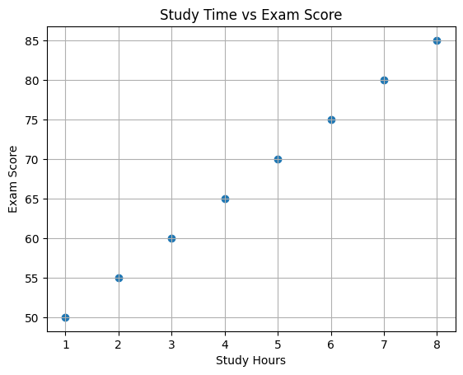
RESULT :
A strong positive correlation exists—students who study more tend to score higher in exams, as shown by the correlation value and visual plots.

